Cleveland Park:
1322 E. Washington Street
Greenville, SC 29607
Fax (864) 235-2512 Ph (864) 235-1200
clevelandpark@rockycreekdental.com
Eastside:
978 Batesville Road
Greer, SC 29651
Fax (864) 675-1134 Ph (864) 675-9399
eastside@rockycreekdental.com

First:
Middle:
Last:

Preferred name:
Minor
Single
Married
Male
Female

Address:
Apt # City State Zip

Home#
Work#
Cell#

DOB: / /
SS#
E-Mail:

How did you hear about us?

Person Responsible for Account *(if different from patient)
Currently a patient in our office? Yes No Relationship to you: Address *(if different from patient)

If Patient is a Minor Parent/Guardian Status: Single Married Divorced Separated Foster Other Child lives with: Parents Mother Father Grandparents Foster Parents Other If divorced, are there court documents that require either parent to carry insurance on child? Yes No (please provide documentation)
If divorced, who has primary custody?

DENTAL INSURANCE (Primary)
Policy Holder: *DOB: / / ID#

EMPLOYER:
Insurance Co.
*(if different from patient) *SS# Insurance Co. Phone #:

Additional Dental Insurance (Secondary)
Policy Holder:

*DOB: / /

ID#

EMPLOYER:
Insurance Co.
*(if different from patient) *SS# Insurance Co. Phone #:

Emergency Contact: Phone#
I understand that I am responsible for payment of services rendered and also responsible for paying any co-
payment and deductibles that my insurance does not cover at the time of service. I hereby authorize release of any information, including the diagnosis and records of treatment or examination rendered, to my insurance company.
Date / /
Patient or Responsible Party

We are pleased to welcome you to our office. New patients are always appreciated. Our practice has grown as a result of excellent relationships with our referring patients and doctors. As our patient, please feel free to express any concerns or ask any questions that you may have. Our doctors and our team will do our best to help.

Office Financial Policy
To assist you in paying for treatment, we offer several payment options. Please read our financial policy below and feel free to discuss it with us.
- Payment for services will be expected in full unless arrangements are made in advance of treatment. Payments can be made with cash, check, ATM/Debit, Visa, MasterCard, American Express, Discover or Care Credit (please ask for details). Any check returned will be assessed a return check fee of $50. In the event that a delinquent account is turned over to an outside collection agency, the patient is responsible for the collection agency fees, which are equal to your balance. This means you will owe twice your outstanding balance, if your account is turned over to an outside collection agency. You will also be dismissed as a patient and we will no longer be able to serve your dental needs.
- Any account with a balance remaining after 90 days will be assessed a fee of 18% annually, regardless of any outstanding insurance claims.

If You Have Insurance
- With your approval, we will file your insurance claims with your insurance carrier. This service is provided at no charge. You can elect to pay your balance in full and have your benefits paid directly to you or you can elect to have benefits paid to our office. If the latter is chosen, we will ESTIMATE your co-pay, due at each appointment. We reserve the right to estimate your benefits based on our previous experience.
- Any balance not covered by your insurance is your responsibility. However, if at any point the insurance company or the insured becomes uncooperative, we reserve the right to terminate acceptance of benefits and collect payment directly from you.

Cancellation Policy
- Our doctors and team at Rocky Creek Dental Care make every attempt to provide you with the highest quality and undivided appointment time for your dental treatment. We reserve this time specifically for you. If you are unable to keep your scheduled appointment, kindly provide us with at least a 48 hour notice. We realize there are true emergencies and unforeseen interruptions in life and we will, of course, take these into consideration. Appointments that are missed or cancelled with less than a 24 hour notice will result in a charge of up to $100 for each scheduled appointment and a non-refundable deposit may be required to schedule future appointments.

Patient’s (or legal guardian’s) signature Date

Medical History

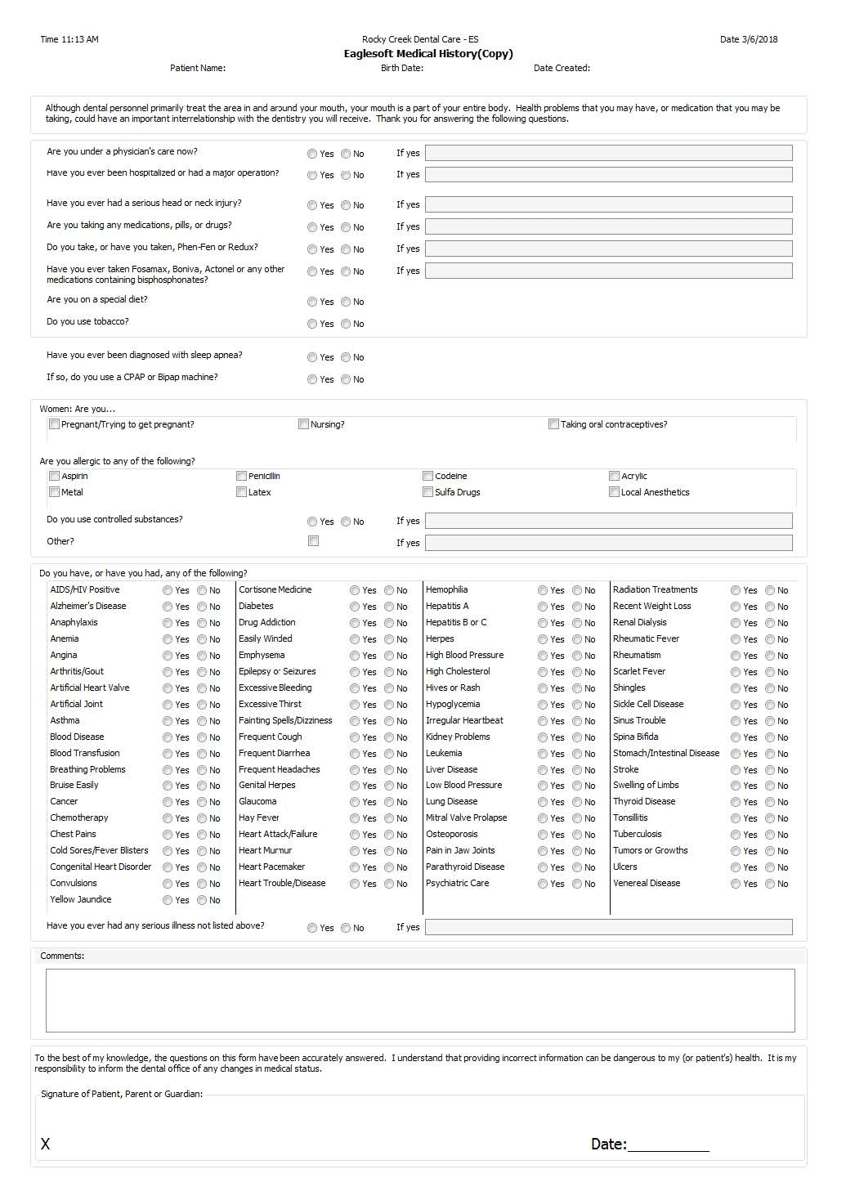
Patient Name:_________________________________________DOB:________________________________________________Date:________________________________
ROCKY CREEK DENTAL CARE SLEEP QUESTIONNAIRE

Name: Date:
DOB: Male Female Ht: Wt:
General Physician:

Please check any of the following you may have:
 | High Blood Pressure | Heart Disease | Diabetes | Stroke | Weight Gain
 | Acid Reflux | Depression | Anxiety | Insomnia | Sleep Apnea

Are you currently using a CPAP machine? Y N If yes, every night? Y N
Have you ever had a Sleep Study? Y N

Do you have frequent headaches? Y N
Do you wake up with soreness or tension in your jaw muscles or teeth? Y N

Y | N | 8 | Have you ever been told you stop breathing while you sleep?
Y | N | 6 | Have you ever fallen asleep or nodded off while driving?
Y | N | 6 | Have you ever woken up suddenly with shortness of breath, gasping, or racing heart?
Y | N | 4 | Do you fight sleepiness during your normal daytime routine?
Y | N | 4 | Do you snore, or have you been told that you snore?
Y | N | 2 | Have you had weight gain and found it difficult to lose?
Y | N | 2 | Have you taken medication for, or been diagnosed with high blood pressure?
Y | N | 3 | Do you kick or jerk your legs while sleeping?
Y | N | 3 | Do you feel burning, tingling or crawling sensations in your legs when you wake up?
Y | N | 3 | Do you wake up with headaches during the night or morning?
Y | N | 4 | Do you have trouble falling asleep?
Y | N | 4 | Do you have trouble staying asleep once you fall asleep?

FOR CLINICAL USE ONLY
Low | Moderate | High | Severe
0 -7 | 8 - 11 | 12 - 15 | 16+

ROCKY CREEK DENTAL CARE
HIPAA AUTHORIZATION

1322 E. Washington St. 978 Batesville Road
Greenville, SC 29607 Greer, SC 29651

Because communication is vital and necessary for patient treatment, this form authorizes us to contact you by leaving messages and/or speaking with family members.

This information includes:

- Appointment / Prescription Refill Reminders
- Preoperative and Postoperative Information
- Treatment or other Information pertinent to your healthcare
- Billing and Collection Information

Date:
Patient’s Name (Please print)

Signature of Patient/Legal Guardian Printed Name of Legal Guardian (if applicable)

*If you would like our office to communicate with you in a more confidential manner, please submit your request in writing for documentation purposes.

-----------------------------------------------------------------------------------------------------

ACKNOWLEDGEMENT OF RECEIPT OF NOTICE OF PRIVACY PRACTICES

I, , have received a copy of this office’s Notice of Privacy Practices.
(Please Print Name)

Date:
Signature of Patient/Legal Guardian

For Office Use Only

We attempted to obtain written acknowledgement or receipt of our Notice of Privacy Practices, but acknowledgement could not be obtained because:

Individual refused to sign An emergency situation prevented us from obtaining acknowledgement
Communications barriers prohibited obtaining the acknowledgement Other (Please specify)

ROCKY CREEK DENTAL CARE

Notice of Privacy Practices

THIS NOTICE DESCRIBES HOW MEDICAL INFORMATION ABOUT YOU MAY BE USED AND DISCLOSED AND HOW YOU CAN GET ACCESS TO THIS INFORMATION. PLEASE REVIEW IT CAREFULLY.

Dental Practice Covered by this Notice
This Notice describes the privacy practices of Rocky Creek Dental Care (“Dental Practice”). “We” and “our” means the Dental Practice. “You” and “your” means our patient.

How to Contact Us/Our Privacy Official
If you have any questions or would like further information about this Notice, you can contact our admin by phone at (864) 884-9214, or by email at eastside@rockycreekdental.com or clevelandpark@rockycreekdental.com.

Our Promise to You and Our Legal Obligations
The privacy of your health information is important to us. We understand that your health information is personal and we are committed to protecting it. This Notice describes how we may use and disclose your protected health information to carry out treatment, payment or health care operations and for other purposes that are permitted or required by law. It also describes your rights to access and control your protected health information. Protected health information is information about you, including demographic information, that may identify you and that relates to your past, present or future physical or mental health or condition and related health care services.
We are required by law to:
- Maintain the privacy of your protected health information; give you this Notice of our legal duties and privacy practices with respect to that information; and Abide by the terms of our Notice that is currently in effect.

Last Revision Date
This Notice was last revised on August 30, 2022.

How We May Use or Disclose Your Health Information
The following examples describe different ways we may use or disclose your health information. These examples are not meant to be exhaustive. We are permitted by law to use and disclose your health information for the following purposes:

Common Uses and Disclosures
    - Treatment. We may use your health information to provide you with dental treatment or services, such as cleaning or examining your teeth or performing dental procedures. We may disclose health information about you to dental specialists, physicians, or other health care professionals involved in your care.
    - Payment. We may use and disclose your health information to obtain payment from health plans and insurers for the care that we provide to you.
    - Health Care Operations. We may use and disclose health information about you in connection with health care operations necessary to run our practice, including review of our treatment and services, training, evaluating the performance of our staff and health care professionals, quality assurance, financial or billing audits, legal matters, and business planning and development.
    - Appointment Reminders. We may use or disclose your health information when contacting you to remind you of a dental appointment. We may contact you by using a postcard, letter, phone call, voice message, text or email.
    - Treatment Alternatives and Health-Related Benefits and Services. We may use and disclose your health information to tell you about treatment options or alternatives or health-related benefits and services that may be of interest to you.
    - Disclosure to Family Members and Friends. We may disclose your health information to a family member or friend who is involved with your care or payment for your care if you do not object or, if you are not present, we believe it is in your best interest to do so.
    - Disclosure to Business Associates. We may disclose your protected health information to our third-party service providers (called, “business associates”) that perform functions on our behalf or provide us with services if the information is necessary for such functions or services. For example, we may use a business associate to assist us in maintaining our practice management software. All of our business associates are obligated, under contract with us, to protect the privacy of your information and are not allowed to use or disclose any information other than as specified in our contract.

Less Common Uses and Disclosures
    - Disclosures Required by Law. We may use or disclose patient health information to the extent we are required by law to do so. For example, we are required to disclose patient health information to the U.S. Department of Health and Human Services so that it can investigate complaints or determine our compliance with HIPAA.

- Public Health Activities. We may disclose patient health information for public health activities and purposes, which include: preventing or controlling disease, injury or disability; reporting births or deaths; reporting child abuse or neglect; reporting adverse reactions to medications or foods; reporting product defects; enabling product recalls; and notifying a person who may have been exposed to a disease or may be at risk for contracting or spreading a disease or condition.
- Victims of Abuse, Neglect or Domestic Violence. We may disclose health information to the appropriate government authority about a patient whom we believe is a victim of abuse, neglect or domestic violence.
- Health Oversight Activities. We may disclose patient health information to a health oversight agency for activities necessary for the government to provide appropriate oversight of the health care system, certain government benefit programs, and compliance with certain civil rights laws.
- Lawsuits and Legal Actions. We may disclose patient health information in response to (i) a court or administrative order or (ii) a subpoena, discovery request, or other lawful process that is not ordered by a court if efforts have been made to notify the patient or to obtain an order protecting the information requested.
- Law Enforcement Purposes. We may disclose your health information to a law enforcement official for a law enforcement purposes, such as to identify or locate a suspect, material witness or missing person or to alert law enforcement of a crime.
- Coroners, Medical Examiners and Funeral Directors. We may disclose your health information to a coroner, medical examiner or funeral director to allow them to carry out their duties.
- Organ, Eye and Tissue Donation. We may use or disclose your health information to organ procurement organizations or others that obtain, bank or transplant cadaveric organs, eyes or tissue for donation and transplant.
- Research Purposes. We may use or disclose your information for research purposes pursuant to patient authorization waiver approval by an Institutional Review Board or Privacy Board.
- Serious Threat to Health or Safety. We may use or disclose your health information if we believe it is necessary to do so to prevent or lessen a serious threat to anyone’s health or safety.
- Specialized Government Functions. We may disclose your health information to the military (domestic or foreign) about its members or veterans, for national security and protective services for the President or other heads of state, to the government for security clearance reviews, and to a jail or prison about its inmates.
- Workers' Compensation. We may disclose your health information to comply with workers' compensation laws or similar programs that provide benefits for work-related injuries or illness.

Your Written Authorization for Any Other Use or Disclosure of Your Health Information
Uses and disclosures of your protected health information that involve the release of psychotherapy notes (if any), marketing, sale of your protected health information, or other uses or disclosures not described in this notice will be made only with your written authorization, unless otherwise permitted or required by law. You may revoke this authorization at any time, in writing, except to the extent that this office has taken an action in reliance on the use of disclosure indicated in the authorization. If a use or disclosure of protected health information described above in this notice is prohibited or materially limited by other laws that apply to use, we intend to meet the requirements of the more stringent law.

Your Rights with Respect to Your Health Information
You have the following rights with respect to certain health information that we have about you (information in a Designated Record Set as defined by HIPAA). To exercise any of these rights, you must submit a written request to our Privacy Official listed on the first page of this Notice.

Right to Access and Review
You may request to access and review a copy of your health information. We may deny your request under certain circumstances. You will receive written notice of a denial and can appeal it. We will provide a copy of your health information in a format you request if it is readily producible. If not readily producible, we will provide it in a hard copy format or other format that is mutually agreeable. If your health information is included in an Electronic Health Record, you have the right to obtain a copy of it in an electronic format and to direct us to send it to the person or entity you designate in an electronic format. We may charge a reasonable fee to cover our cost to provide you with copies of your health information.

Right to Amend
If you believe that your health information is incorrect or incomplete, you may request that we amend it. We may deny your request under certain circumstances. You will receive written notice of a denial and can file a statement of disagreement that will be included with your health information that you believe is incorrect or incomplete.

Right to Restrict Use and Disclosure
You may request that we restrict uses of your health information to carry out treatment, payment, or health care operations or to your family member or friend involved in your care or the payment for your care. We may not (and are not required to) agree to your requested restrictions, with one exception: If you pay out of your pocket in full for a service you receive from us and you request that we not submit the claim for this service to your health insurer or health plan for reimbursement, we must honor that request.

Right to Confidential Communications, Alternative Means and Locations
You may request to receive communications of health information by alternative means or at an alternative location. We will accommodate a request if it is reasonable and you indicate that communication by regular means could endanger you. When you submit a written request to the Privacy Official listed on the first page of this Notice, you need to provide an alternative method of contact or alternative address and indicate how payment for services will be handled.

Right to an Accounting of Disclosures
You have a right to receive an accounting of disclosures of your health information for the six (6) years prior to the date that the accounting is requested except for disclosures to carry out treatment, payment, health care operations (and certain other exceptions as provided by HIPAA). The first accounting we provide in any 12-month period will be without charge to you. We may charge a reasonable fee to cover the cost for each subsequent request for an accounting within the same 12-month period. We will notify you in advance of this fee and you may choose to modify or withdraw your request at that time.

Right to a Paper Copy of this Notice
You have the right to a paper copy of this Notice. You may ask us to give you a paper copy of the Notice at any time (even if you have agreed to receive the Notice electronically). To obtain a paper copy, ask the Privacy Official.

Right to Receive Notification of a Security Breach
We are required by law to notify you if the privacy or security of your health information has been breached. The notification will occur by first class mail within sixty (60) days of the event. A breach occurs when there has been an unauthorized use or disclosure under HIPAA that compromises the privacy or security of your health information.
The breach notification will contain the following information: (1) a brief description of what happened, including the date of the breach and the date of the discovery of the breach; (2) the steps you should take to protect yourself from potential harm resulting from the breach; and (3) a brief description of what we are doing to investigate the breach, mitigate losses, and to protect against further breaches.

Special Protections for HIV, Alcohol and Substance Abuse, Mental Health and Genetic Information
Certain federal and state laws may require special privacy protections that restrict the use and disclosure of certain health information, including HIV-related information, alcohol and substance abuse information, mental health information, and genetic information. For example, a health plan is not permitted to use or disclose genetic information for underwriting purposes. Some parts of this HIPAA Notice of Privacy Practices may not apply to these types of information. If your treatment involves this information, you may contact our office for more information about these protections.

Our Right to Change Our Privacy Practices and This Notice
We reserve the right to change the terms of this Notice at any time. Any change will apply to the health information we have about you or create or receive in the future. We will promptly revise the Notice when there is a material change to the uses or disclosures, individual’s rights, our legal duties, or other privacy practices discussed in this Notice. We will post the revised Notice on our website (if applicable) and in our office and will provide a copy of it to you on request. The effective date of this Notice is 10-01-2013.

How to Make Privacy Complaints
If you have any complaints about your privacy rights or how your health information has been used or disclosed, you may file a complaint with us by contacting our Privacy Official listed on the first page of this Notice.
You may also file a written complaint with the Secretary of the U.S. Department of Health and Human Services, Office for Civil Rights. We will not retaliate against you in any way if you choose to file a complaint.

